Chapter – 5
Design Simulation and Results

5.1 Design Simulation Battery charging Technology and Power Integration
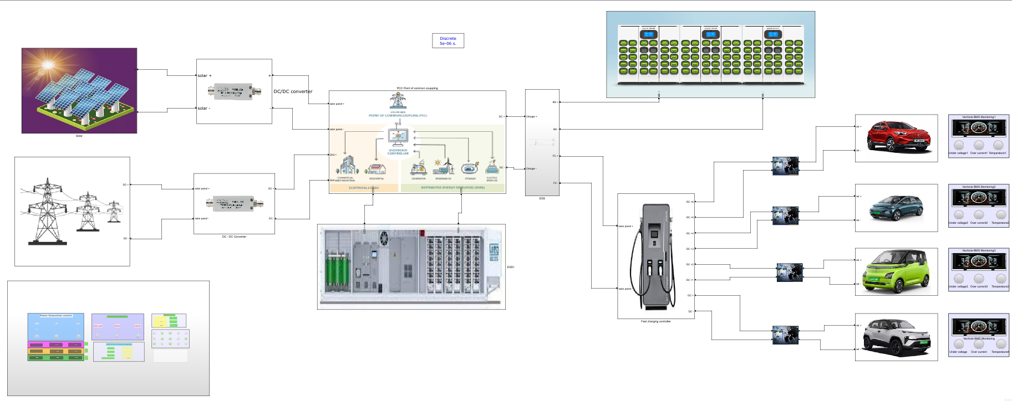
Fig 15 : Simulation of Battery charging Technology and Power Integration
The MATLAB simulation for the proposed battery charging management system integrates solar energy, Energy Storage Systems (ESS), and grid power at the Point of Common Coupling (PCC). This innovative architecture is designed to optimize the charging process for electric vehicles (EVs) while ensuring efficient utilization of available energy resources. By connecting these three energy sources, the system can dynamically manage energy flows based on real-time conditions, prioritizing solar power first, followed by stored energy from the ESS, and utilizing grid electricity as a backup when necessary.
At the PCC, the simulation also connects battery swapping stations and fast charging units, allowing for flexible and efficient energy distribution to meet varying demand levels. The integration of these components enables the system to adapt to fluctuations in energy production and consumption effectively. Each parameter related to battery performance—such as voltage, current, State of Charge (SOC), and temperature—is continuously monitored through an Internet of Things (IoT) architecture. This real-time data collection facilitates proactive management of charging operations and ensures optimal battery health.
The proposed IoT architecture consists of five distinct layers: User Interface Application Layer, Cloud Server and Data Storage, Communication Layer, Microcontroller Layer, and Sensor Layer. This layered approach allows for centralized monitoring and control, enabling users to track charging status and energy consumption easily. Additionally, predictive analytics within the cloud server help forecast power demand and optimize charging schedules based on historical data and current usage patterns.
Preliminary simulations indicate a significant reduction in operational costs—up to 90%—through optimized resource utilization. The integration of renewable energy sources not only enhances sustainability but also addresses the growing demand for efficient EV charging infrastructure. By leveraging MATLAB simulations to model this complex system before physical implementation, the project aims to refine its design and ensure its effectiveness in real-world applications.
5.1.1 Solar Generation Unit
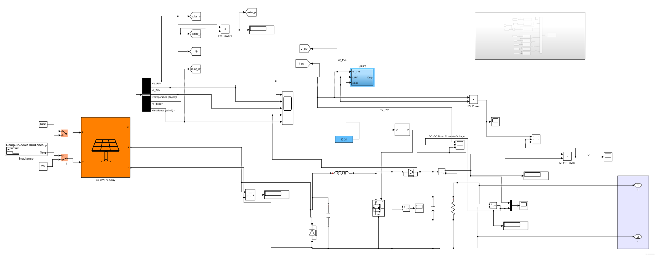
Fig 16 : Solar generation unit
The solar generation unit in this project is designed with a capacity of 30 kW, making it a significant contributor to the overall energy management system. This submodule operates efficiently by generating approximately 60% of its rated solar power, which translates to a practical output under optimal conditions. Specifically, the system produces a voltage of 212 V and a current of 120 A, resulting in a power output of 26 watts during standard operating conditions.
To enhance the energy output and adapt to the requirements of the battery charging management system, the solar generation unit is connected to a DC Boost Converter. This converter plays a critical role in stepping up the voltage from the solar panels. After processing through the boost converter, the output is increased to 430 V with a current of 94 A, yielding an effective power output of 40 watts. This conversion is essential for ensuring that the energy produced can be efficiently utilized for charging batteries or feeding into the grid.
The integration of this solar generation submodule into the overall IoT architecture allows for real-time monitoring and optimization of energy production. By leveraging advanced data analytics, the system can dynamically adjust operations based on solar availability, battery state of charge, and overall energy demand. This capability not only enhances the efficiency of the charging process but also contributes to sustainability by maximizing the use of renewable energy sources.
This solar generation unit, with its 30-kW capacity and effective integration with a DC Boost Converter, plays a pivotal role in supporting the project's goals of efficient battery charging management and promoting renewable energy utilization within the framework of an IoT-enabled infrastructure.

5.1.2 Grid Generation Unit
The integration of the grid unit into the battery charging management system is a critical component that enhances the overall efficiency and reliability of the energy supply for electric vehicle (EV) charging. In this project, the grid unit is designed to operate at an output voltage of 430 V, with a current capacity of 177 A, resulting in a power output of 51 watts. This configuration allows the system to effectively manage energy demands by providing a stable power source when solar generation and energy storage are insufficient.
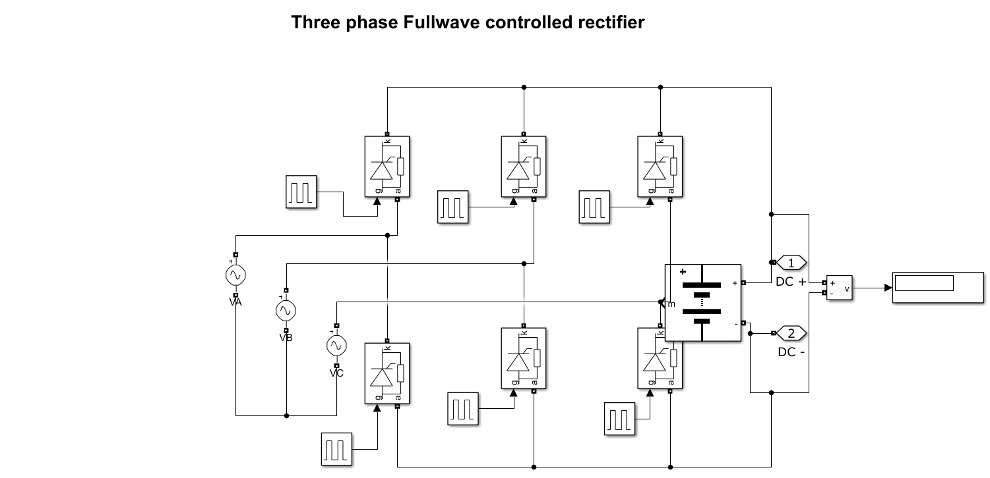
Fig 17 : Grid Generation unit
The grid unit serves as a backup power source, ensuring that charging operations can continue uninterrupted during periods of low solar energy generation or when the Energy Storage System (ESS) is depleted. This capability is essential for maintaining service availability, particularly in scenarios where EV charging demand peaks.
By integrating the grid unit at the Point of Common Coupling (PCC), the system can balance loads effectively between solar power, ESS, and grid electricity. This load management ensures optimal resource utilization, reducing reliance on any single energy source and enhancing overall system resilience. The grid unit allows for dynamic adjustments based on real-time data analytics. When solar generation is high, the system prioritizes solar energy for charging; however, if solar output drops below a certain threshold, the grid unit can automatically supplement power to maintain consistent charging operations.
The integration of the grid unit facilitates comprehensive monitoring and control capabilities within the IoT architecture. The system continuously tracks key parameters such as voltage, current, and overall power output from the grid, allowing for proactive management and timely interventions if anomalies are detected. The grid unit’s integration supports advanced smart charging solutions that can optimize energy costs based on real-time electricity pricing. This feature enables users to take advantage of lower rates during off-peak hours, further enhancing cost efficiency.
The integration of the grid unit into the battery charging management system plays a vital role in ensuring reliable and efficient EV charging operations. By providing a stable power source with an output of 430 V and 177 A, it enhances load balancing, supports dynamic energy management, and facilitates comprehensive monitoring within the IoT architecture. This integration not only improves operational efficiency but also contributes to a more sustainable energy ecosystem by optimizing the use of renewable resources alongside traditional grid power.
5.1.3 ESS Energy Storage system
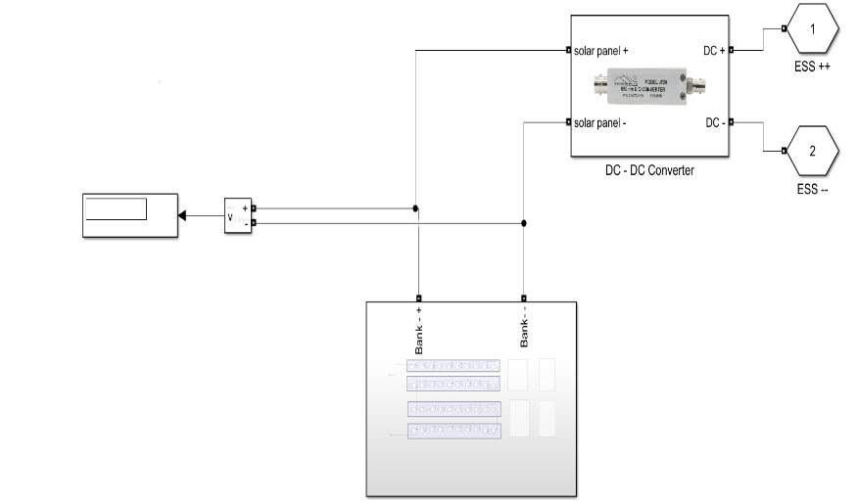
The Energy Storage System (ESS) in this project is designed to significantly enhance the efficiency and reliability of the battery charging management system by utilizing 40 lead-acid batteries, each with a capacity of 12V and 100Ah. This configuration results in a total power bank capable of supplying 480V at a current of 140A, yielding an overall power output of 68 watts. The integration of this ESS is crucial for managing energy supply effectively, particularly in scenarios where solar generation is insufficient or during peak demand periods for electric vehicle (EV) charging.
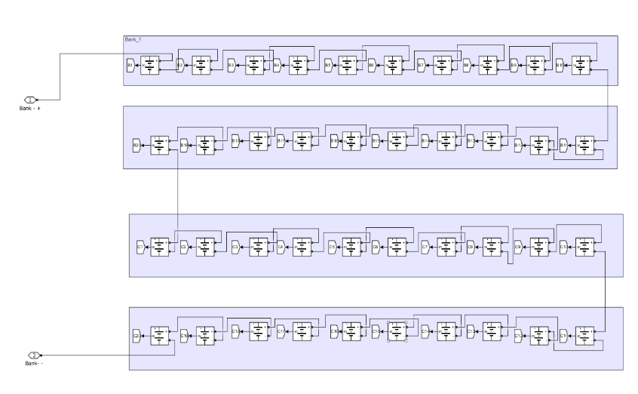

Fig 18 : BESS Battery Energy Storage System

The ESS acts as a buffer that stores excess energy generated from solar panels during peak sunlight hours. This stored energy can then be utilized when solar generation is low or when demand exceeds the available solar output, ensuring a continuous power supply for EV charging.
By integrating the ESS at the Point of Common Coupling (PCC), the system can efficiently manage loads between solar power, grid electricity, and stored energy. This load balancing capability allows for optimal resource utilization, reducing reliance on any single energy source and enhancing overall system resilience.
The ESS improves charging efficiency by providing a stable voltage and current output to the battery swapping stations and fast charging units. This stability is essential for maintaining battery health and ensuring quick charging times for EVs. The ESS is equipped with monitoring capabilities that track key parameters such as State of Charge (SOC), voltage, and temperature. This real-time data is integrated into IoT architecture, allowing for proactive management of charging operations and timely interventions if any anomalies are detected.
By maximizing the use of renewable energy sources, the ESS contributes to the sustainability goals of the project. It enables the system to reduce its carbon footprint by relying more on solar energy while ensuring that energy demands are met efficiently.
The integration of the Energy Storage System (ESS) comprising 40 lead-acid batteries into the battery charging management system plays a vital role in enhancing operational efficiency and reliability. With a capacity to supply 480V at 140A, this ESS not only buffers energy but also facilitates load management and improves charging efficiency. By leveraging real-time monitoring within an IoT framework, the system ensures optimal performance while promoting sustainable practices through effective utilization of renewable energy sources. This comprehensive approach positions the project as a forward-thinking solution in the rapidly evolving landscape of electric vehicle infrastructure.

5.1.4 PCC – Point of common coupling and Power Source Integration and Automation
Automation Logic for Point of Common Coupling (PCC)
The automation logic for the Point of Common Coupling (PCC) in the battery charging management system is designed to optimize energy flow from solar power, Energy Storage Systems (ESS), and grid electricity based on real-time conditions.
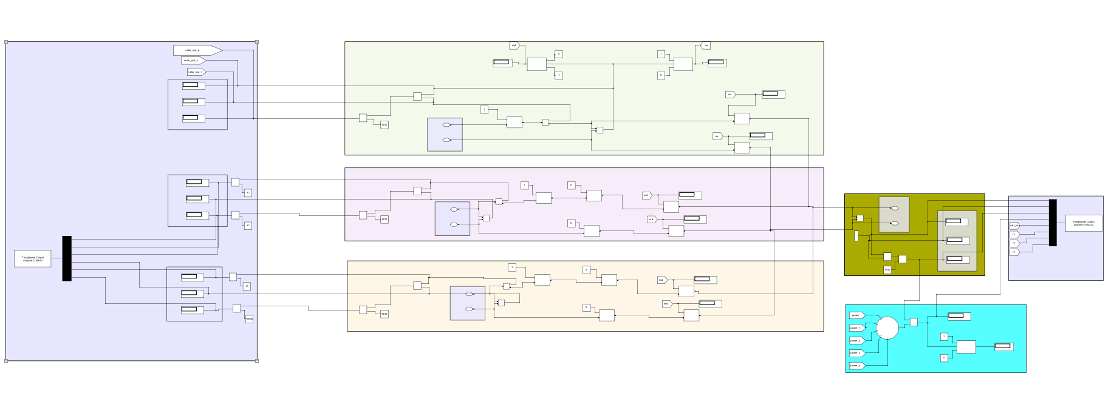
Fig 19 : PCC Point of Coming Coupling
The following conditions outline the operational states and corresponding actions for efficient energy management:
Solar ON → ESS Charge → Grid OFF → Load ON:
When solar energy is available, the system prioritizes charging the ESS using the generated solar power.
The grid connection is turned off to maximize the use of renewable energy.
The load (e.g., EV charging stations) is activated to utilize the available solar energy, ensuring efficient energy consumption.
Solar ON → ESS > 80% → [Grid DC-AC] ON → Load ON:
If solar generation is active and the State of Charge (SOC) of the ESS exceeds 80%, the system allows for grid connection.
The grid is converted from DC to AC to support additional loads or provide power to the grid if necessary.
The load remains on, benefiting from both solar and grid power to meet demand.

Solar OFF → ESS ON → Grid OFF → Load ON:
In scenarios where solar generation is not available, but the ESS has sufficient charge, the system will utilize stored energy from the ESS.
The grid remains disconnected to ensure that all energy supplied to the load comes from the ESS.
This configuration maintains continuous operation of loads even in the absence of solar power.
Solar OFF → ESS < 20% → [Grid DC-AC] ON → Load ON:
If solar generation is absent and the SOC of the ESS falls below 20%, indicating low stored energy, the system activates the grid connection.
The grid is converted from DC to AC to provide necessary power to maintain load operations.
This ensures that critical loads are powered even when renewable sources are insufficient, preventing service interruptions.
The automation logic for PCC effectively manages energy flows between solar power, ESS, and grid electricity based on real-time conditions. By prioritizing renewable energy usage while ensuring reliable backup power from the grid, this system enhances operational efficiency and sustainability in electric vehicle charging infrastructure. The integration of these automated controls within an IoT framework allows for real-time monitoring and management, optimizing performance and user experience.
5.1.5 Battery Swapping System
The Battery swapping stations play a crucial role in the evolving landscape of electric vehicle (EV) infrastructure, particularly in enhancing the efficiency and convenience of battery management. The integration of 30 lithium-ion batteries, each rated at 12V and 10A, connected to the Point of Common Coupling (PCC), underscores the significance of these stations in supporting sustainable transportation solutions.
One of the primary advantages of battery swapping stations is their ability to provide quick refueling options for electric vehicles. Unlike traditional charging methods that can take hours, battery swapping allows drivers to replace depleted batteries with fully charged ones in a matter of minutes. This significantly reduces downtime and enhances the overall user experience.

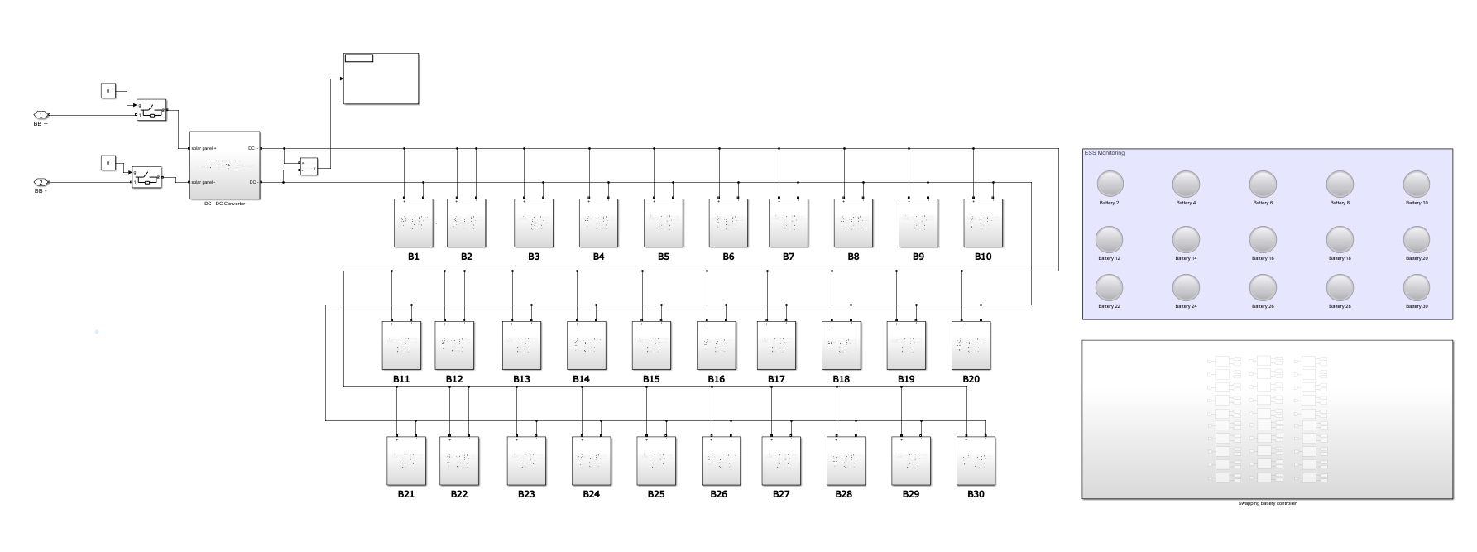
Fig 20 : Battery Swapping Station
Increased Range and Flexibility: By utilizing battery swapping technology, EV users can extend their driving range without the anxiety associated with long charging times. This flexibility is particularly beneficial for commercial fleets and ride-sharing services that require quick turnaround times to maximize operational efficiency.
The integration of lithium-ion batteries in swapping stations allows for centralized battery management, which can improve battery health and longevity. The system can monitor the State of Charge (SOC), temperature, and overall performance of each battery, ensuring that only batteries in optimal condition are deployed to vehicles. This proactive approach helps maintain high performance across the fleet.
Battery swapping stations can be strategically located near renewable energy sources, such as solar power systems integrated at the PCC. This setup allows for efficient energy management, where excess solar energy can be stored in swapped batteries during peak generation times, promoting sustainability and reducing reliance on grid power.
The data collected from battery swapping operations can be analyzed to optimize charging schedules and energy distribution. By integrating with IoT technologies, these stations can dynamically adjust operations based on real-time demand and energy availability, further enhancing operational efficiency. As the demand for electric vehicles continues to grow, battery swapping stations offer a scalable solution that can adapt to changing market conditions. They can be easily expanded or modified to accommodate more batteries or integrate with additional energy sources, ensuring that the infrastructure keeps pace with technological advancements and consumer needs.

5.1.6 Dc Fast Charging
The DC fast charging stations are a pivotal component in the infrastructure supporting electric vehicles (EVs), addressing the growing need for quick and efficient charging solutions. These stations utilize direct current (DC) to deliver high power levels, significantly reducing charging times compared to traditional AC charging methods. The integration of DC fast charging stations within the proposed IoT architecture for battery charging management enhances the overall efficiency and user experience in EV operations.
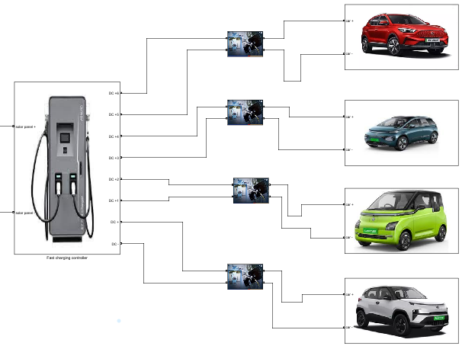
Fig 21 : DC Fast Charging Station
One of the primary advantages of DC fast charging stations is their ability to charge EV batteries quickly, often reaching 80% charge in as little as 30 minutes. This rapid refueling capability is essential for users who require quick turnaround times, such as fleet operators and long-distance travelers. By providing fast charging options, these stations alleviate range anxiety among EV users, allowing them to travel longer distances without the fear of running out of power. This convenience encourages more consumers to adopt electric vehicles, contributing to a sustainable transportation ecosystem.
The proposed system integrates DC fast charging stations with renewable energy sources like solar power and Energy Storage Systems (ESS). This integration allows for efficient energy management, where excess solar energy can be utilized for fast charging, promoting sustainability and reducing reliance on grid electricity.
The DC fast charging stations are designed to handle higher power levels, making them suitable for commercial applications and public charging networks. By accommodating multiple vehicles simultaneously, these stations can support high demand in urban areas and along major travel routes.Within the IoT architecture, DC fast charging stations are equipped with monitoring capabilities that track key parameters such as voltage, current, and State of Charge (SOC).
This data is transmitted to the cloud for analysis, enabling predictive maintenance and optimizing charging schedules based on real-time demand. The modular design of DC fast charging stations allows for easy scalability as the demand for EV charging increases. This flexibility enables operators to expand their infrastructure quickly, adapting to changing market conditions and consumer needs.
5.1.7 Simulation Monitoring Data.
The MATLAB simulation for the battery charging management system provided a comprehensive platform for monitoring and visualizing critical parameters related to power sources and load operations at the charging station. By integrating various energy sources, including solar power, Energy Storage Systems (ESS), and grid electricity, the simulation enabled real-time data collection and analysis, which are vital for optimizing charging efficiency.
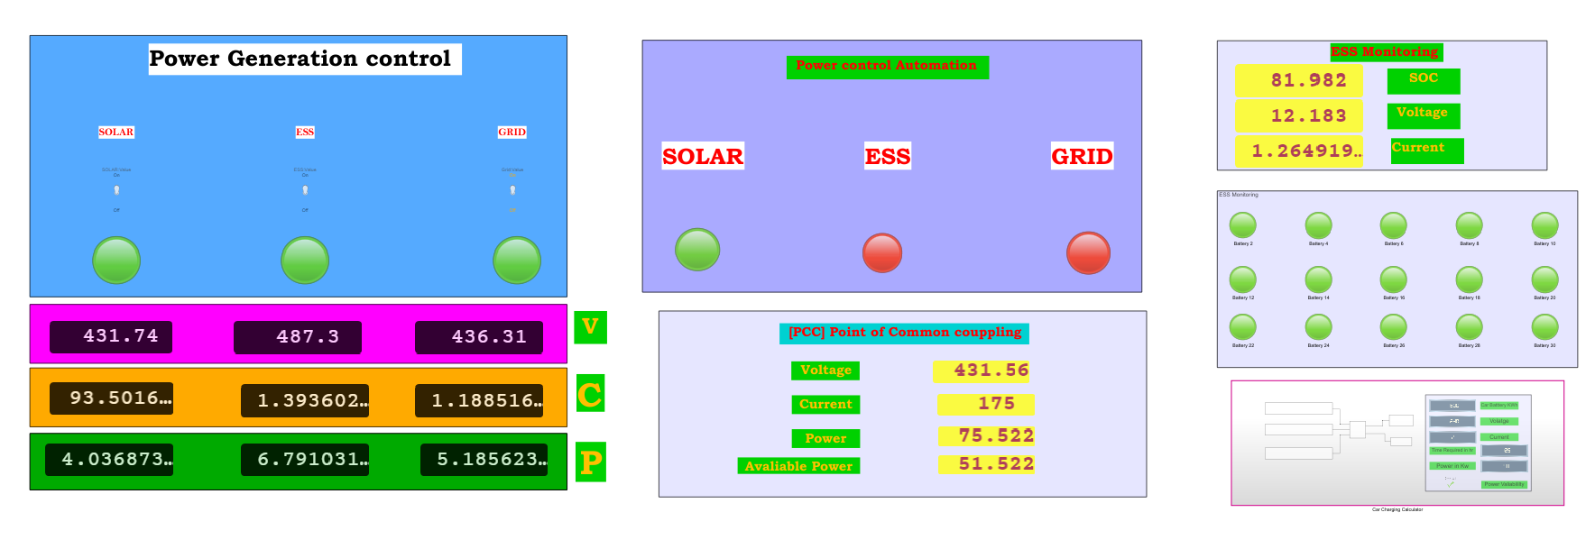
Fig 22 : Parameters Data monitoring
Throughout the simulation, key parameters such as voltage, current, State of Charge (SOC), and power output from each energy source were continuously monitored. Visualization tools within MATLAB allowed for the representation of this data in dynamic graphs and charts, facilitating a clear understanding of how different components interact within the system. For instance, the simulation illustrated how solar energy is prioritized during peak generation times, with excess energy directed towards charging the ESS while maintaining load operations for electric vehicles.
The calculated results from the simulation indicated significant improvements in operational efficiency. By effectively managing energy flows and optimizing resource utilization, the system demonstrated potential cost savings of up to 90%. This was achieved through strategic automation of charging schedules based on real-time demand and predictive analytics that forecast energy needs.
The visualization results highlighted the performance metrics of the battery swapping stations and DC fast charging units, showcasing their responsiveness to varying energy availability. The integration of these features within an IoT framework not only enhances user experience by providing real-time insights into charging status but also supports sustainable practices by maximizing the use of renewable energy sources.
5.2 Node Red
The integration of MATLAB with ThingSpeak and Node-RED forms a critical component of the proposed IoT architecture for battery charging management, facilitating real-time data monitoring, analysis, and visualization. In this setup, MATLAB serves as the primary platform for collecting and processing data from various parameters related to power sources and load operations at the charging station. This includes key metrics such as voltage, current, State of Charge (SOC), and overall power output from solar panels, Energy Storage Systems (ESS), and grid electricity.
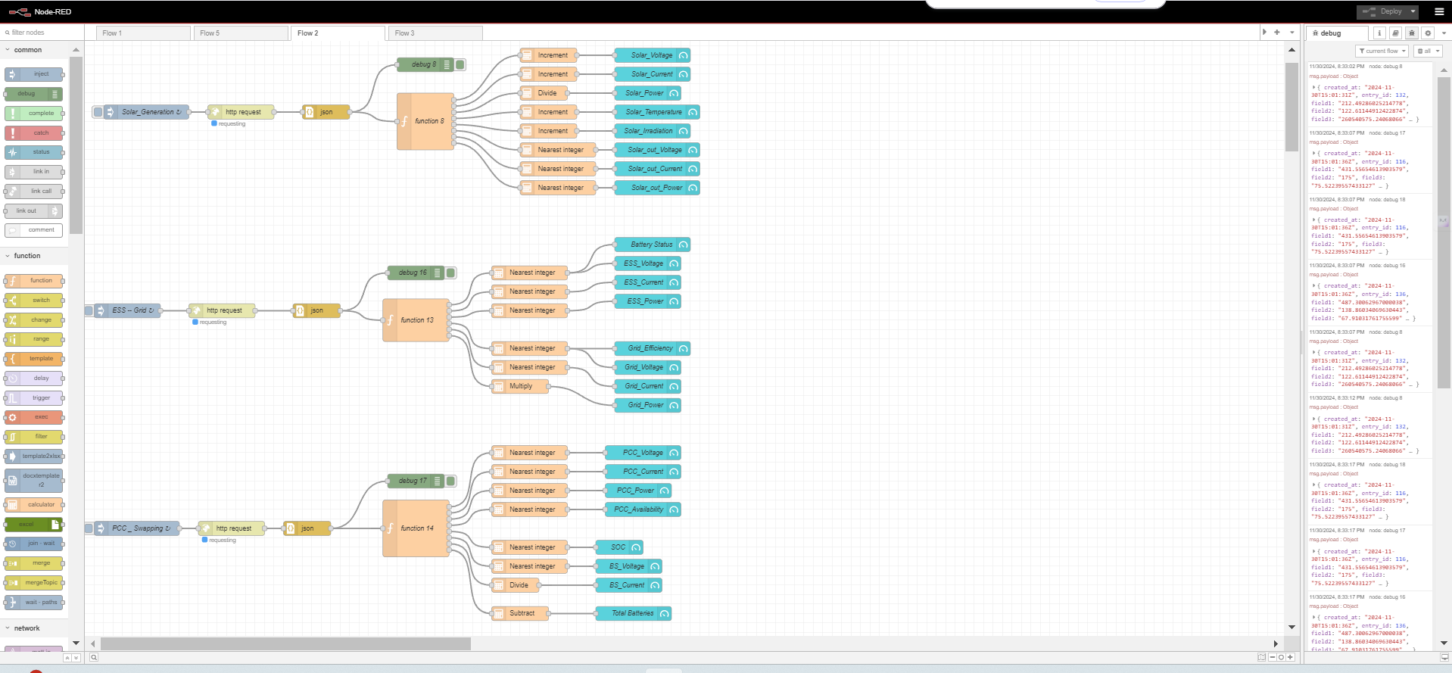
Fig 23 : Node-Red Data mapping and monitoring
Once the data is generated in MATLAB, it is sent to ThingSpeak, a cloud-based IoT analytics platform that allows for the storage and analysis of time-series data. ThingSpeak provides a robust environment for aggregating data from multiple sources, enabling users to visualize trends and patterns over time. This capability is essential for monitoring the performance of the battery charging management system, as it allows stakeholders to assess how effectively energy resources are being utilized.
Following the data upload to ThingSpeak, the information is then transmitted to Node-RED, a flow-based programming tool that facilitates the customization and visualization of data for various actions. In Node-RED, users can create custom dashboards that display real-time information on charging status, energy consumption, and other critical parameters. This visual representation enhances user engagement by providing intuitive access to system performance metrics. Additionally, Node-RED enables automation of specific actions based on predefined conditions; for example, it can trigger alerts when SOC levels drop below a certain threshold or when energy production from solar panels exceeds expectations.

The seamless flow of data from MATLAB to ThingSpeak and then to Node-RED exemplifies an effective IoT architecture that enhances operational efficiency in battery charging management. By leveraging these technologies, the system not only optimizes energy usage but also supports proactive decision-making through real-time analytics. This integration ultimately contributes to a more sustainable transportation ecosystem by maximizing the utilization of renewable energy sources while ensuring reliable service availability for electric vehicle users.
The collaboration between MATLAB, ThingSpeak, and Node-RED within this IoT framework provides a comprehensive solution for monitoring and managing battery charging operations. The ability to visualize and analyze data in real-time empowers users to make informed decisions that enhance efficiency and sustainability in electric vehicle infrastructure. Future developments will focus on refining these integrations further to expand capabilities and improve user experience in managing energy resources effectively.
5.2.1 Solar Visualization
The visualization of solar energy generation allows users to track the amount of energy produced by solar panels in real-time, facilitating effective management of renewable resources. By displaying key metrics such as voltage, current, and power output, users can assess the efficiency of solar energy utilization and make informed decisions about energy distribution.
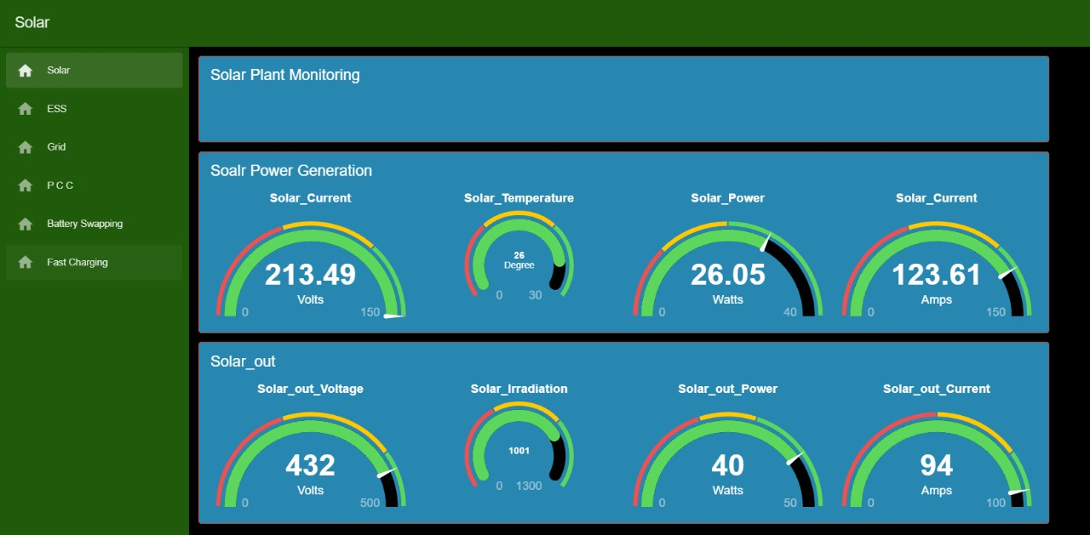
Fig 24 : Solar Data Visualization
5.2.2 ESS Visualization
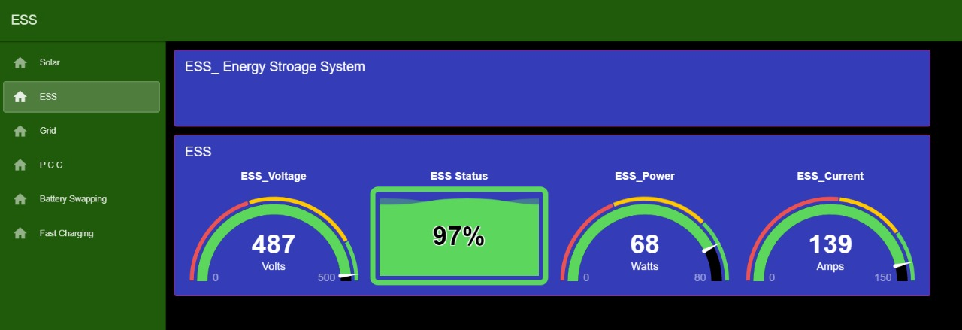
Fig 25 : ESS Visualization
The ESS section of the dashboard provides critical information regarding the state of charge (SOC) of the batteries, enabling users to monitor energy storage levels and optimize charging cycles. This real-time monitoring ensures that the ESS is adequately charged during peak solar production times, allowing for efficient energy use when solar generation is low.
5.2.3 Grid Power Visualization
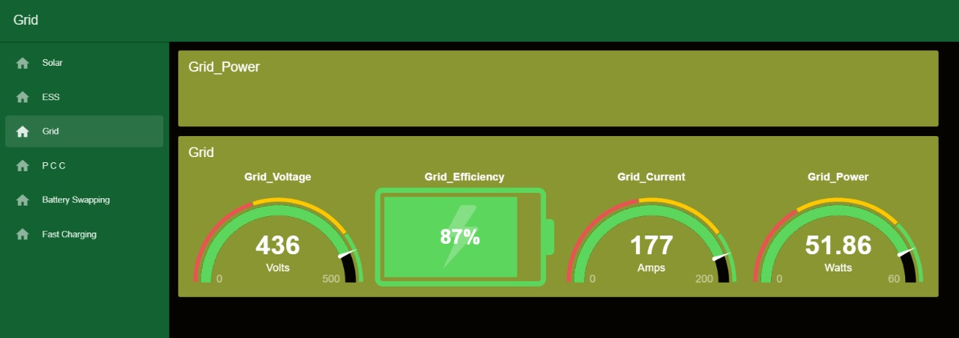
Fig 26 : Grid Power Visualization
Grid power visualization is essential for understanding how much electricity is being drawn from or fed into the grid. This feature supports load management by indicating when to rely on grid power versus stored energy from the ESS or solar generation, thereby optimizing operational costs and enhancing sustainability.

5.2.4 PCC Visualization
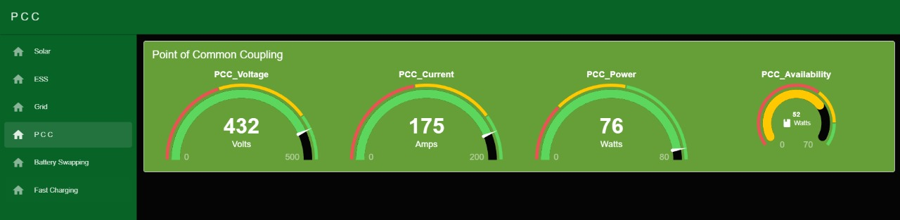
Fig 27 : PCC Visualization
The PCC section integrates data from all connected sources, displaying how energy flows between solar panels, ESS, and grid power. This holistic view enables users to manage loads effectively and ensure that energy is utilized efficiently across all components of the system.
5.2.5 Battery Swapping and Fast charging Station Visualization.
The dashboard includes visual representations for battery swapping stations and fast charging units. Users can monitor the status of available batteries for swapping and track fast charging operations, ensuring that EVs can be serviced quickly and efficiently. This capability enhances user convenience and promotes higher turnover rates at charging stations.
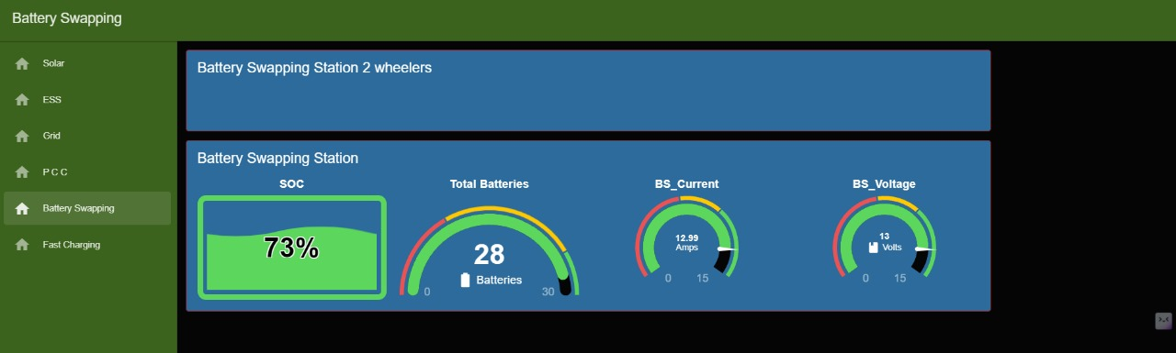
Fig 28 : Battery Swapping Station Visualization
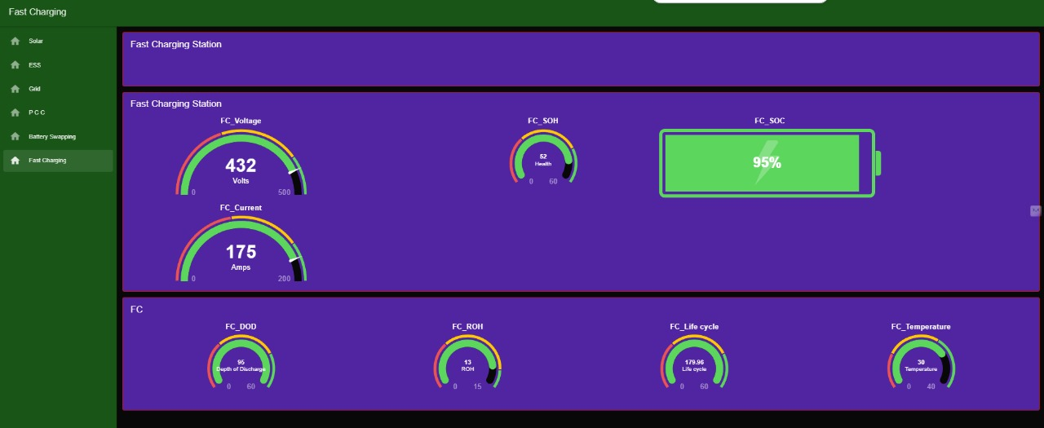
Fig 29 : DC Fast Charging Station Visualization
5.3 AWS – Integration
In the proposed battery charging management system, Amazon Web Services (AWS) plays a pivotal role in data storage, notification management, and visualization, enhancing the overall functionality and reliability of the system. By utilizing AWS, the project ensures that critical data collected from various components of the charging infrastructure is securely stored and easily accessible for analysis and reporting.
5.3.1 Data Storage in Amazon S3
Amazon Simple Storage Service (S3) is employed to store vast amounts of data generated by the system, including metrics related to solar energy production, Energy Storage System (ESS) performance, grid power usage, and battery swapping operations. S3 provides a highly scalable and durable storage solution that allows for efficient data management without the constraints of traditional storage systems. This centralized data repository enables easy retrieval and analysis of historical data, facilitating insights into system performance over time.

Fig 30 : Data storage in AWS S3 Bucket

5.3.2 Email Alerts with Amazon SNS
To enhance operational efficiency and ensure proactive management, AWS integrates Amazon Simple Notification Service (SNS) for sending email alerts based on predefined conditions. For instance, if the State of Charge (SOC) of the ESS falls below a certain threshold or if there is an anomaly detected in energy production or consumption, SNS can automatically trigger email notifications to relevant stakeholders. This capability ensures that operators are promptly informed of critical situations, allowing for timely interventions to maintain optimal system performance.

Fig 31 : AWS SNS Email Alerts
5.3.3 Visualization with Amazon QuickSight
AWS also provides powerful visualization capabilities through Amazon QuickSight, a business intelligence service that allows users to create interactive dashboards and visualizations from the data stored in S3. By integrating QuickSight into the battery charging management system, stakeholders can gain valuable insights into key performance indicators (KPIs) such as energy production trends, charging efficiency metrics, and overall operational statistics. Custom dashboards can be designed to display real-time data analytics, enabling users to monitor system performance effectively and make informed decisions based on visualized data.
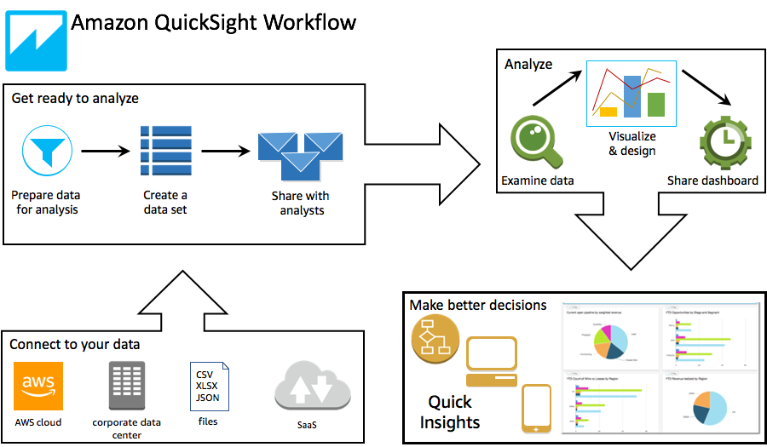
Fig 32 : AWS QuickSlights flow

